THE NATIONAL PARENTING CENTER HAS ISSUED
ITS FINAL REPORT

After 35 Years, The Revered Award Company Is Closing Its Doors

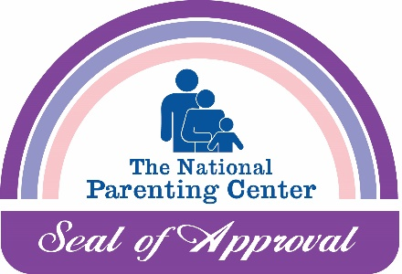
Oak Park, CA (November 22, 2024) -- The National Parenting Center was launched in 1989, with the intention of providing parents with invaluable child-rearing support and advice from top parenting experts. The initial ill-fated foray into the nascent 900-line business required a quick pivot to the internet's earliest days and a partnership with Prodigy, the world's first content service. From there, the agency moved to America Online and then to the web, all part of trying to stay ahead of the curve, shrewdly navigated by its founder and president, David Katzner.
The Seal of Approval program was created in 1990. The testing and review process made The National Parenting Center Seal of Approval one of the most sought-after and prestigious awards due to the rigorous testing model it created, and the insightful, thoughtful and thorough reviews the agency wrote based on feedback from family testers.
When the Seal program was launched, there were only three other review programs of any note in the industry. Parents’ Choice Foundation and Dr. Toy, which closed down years ago, and Oppenheim Toy Portfolio, which is still running today. Since that time, others have tried and failed to enter the space, but The National Parenting Center has remained. Over the years, it reviewed over 12,000 products and services from 1900 different companies. Today, some of its family testers/reviewers grew up with parents who were reviewers themselves, a testament to its longevity and commitment to its audience, parents around the world.
“Between the hundreds of parent advice articles and the Seal of Approval reviews, we have hosted and helped tens of millions of parents with responsible, helpful, and supportive content on our website,” said David Katzner. “I am proud of the legacy we leave behind, and of both the work we have done and the lives we have touched.”
However, as time passed and the internet grew and morphed into what people know today, shopping sites such as Amazon, watered down the import of reputable review services with their random 5-star reviews where anyone with an opinion can make or break a product's success.
The business will be fondly remembered by the countless families whose lives were improved by the guidance of the thrice-yearly Reports and better playthings and services resulting from them, as well as by PR agencies and businesses that tapped into the business’s vast network of families who relied upon The National Parenting Center for sound advice. The 2024 Holiday Seal of Approval Report, which was published last week, is the last word. The website will live on for years to come, so families can continue to revisit when searching for quality parenting advice as well as for gift ideas and purchases.
“It’s melancholy to be saying goodbye, but it’s time. I also feel deeply grateful for having played a part, pun intended, in the toy and juvenile industry for so many years,” Katzner said. “I will continue to work with companies and colleagues in the industry, lending advice and guidance when and where I can. It has been an honor to be part of this industry, and I look forward to being able to give back to it.”

